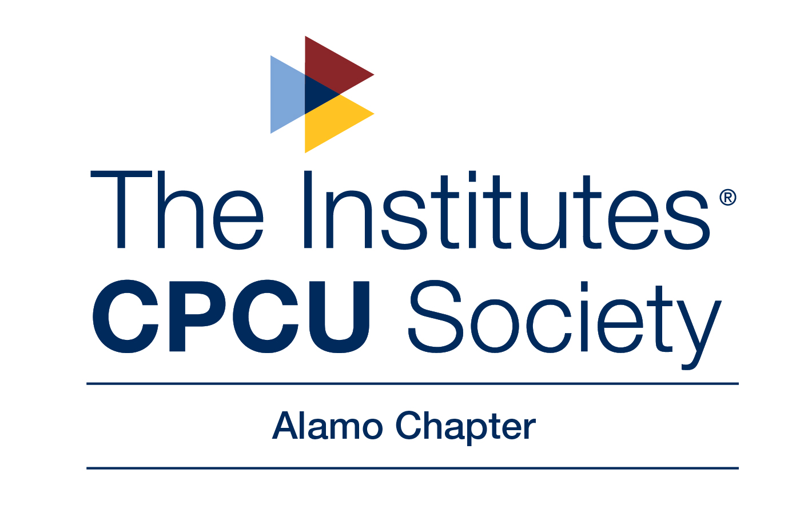

Welcome to the
Alamo Chapter Virtual I-Day

Strong Connections

August 26th and 27th, 2021

Virtual Meeting Via Zoom
Join Zoom Meeting
https://us02web.zoom.us/j/83237883673?pwd=SEt6UER4akFMd2E5TXNLSG9jZG1Udz09

Meeting ID: 832 3788 3673
Passcode: 138600
One tap mobile
+13462487799,,83237883673#,,,,*138600# US (Houston)
+16699006833,,83237883673#,,,,*138600# US (San Jose)

Dial by your location
+1 346 248 7799 US (Houston)
+1 669 900 6833 US (San Jose)
+1 253 215 8782 US (Tacoma)
+1 929 205 6099 US (New York)
+1 301 715 8592 US (Washington DC)
+1 312 626 6799 US (Chicago)
Meeting ID: 832 3788 3673
Passcode: 138600
Find your local number: https://us02web.zoom.us/u/keb7RVEoGl
hedule Subject to Change:

8am – 9:15am:
9am – 9:03am:
9:03am – 10:00am:
10:10am – 11:10am:
11:10am – 12:30pm:
12:30pm – 12:45pm:
1pm – 1:50pm:
2pm – 2:50pm:
3pm – 3:50pm:
*
1pm – 2pm:
*
2:30pm – 4:30pm:
1:45pm – 4pm:
4pm – 4:10pm:
4:10pm – 4:55pm:
Registration and Breakfast
Cherie Bracher, CPCU– Alamo Chapter President Welcome
Abi Potter Clough, CPCU, MBA – Personal Brand
Logan Scherschel – Wildfire Risk
Lunch / Alex Garcia, Keynote Speaker – Forecasting
Susan Golla, CPCU – New Designee Conferment
Michael Gonzales, MBA, JD – Concurrent Causation
Aaron Wright, FCAS, CSPA, CPCU – Data Science Needs You!
Tom Woods, CPCU, Dr. Sommer, Cristina Martin – Panelists
Rimkus CE - Property Damage Assessments - Catastrophe
National Alliance for Insurance Education & Research CE - Ethics
Afternoon snacks
Raffles
Susie Quintana, MPH, CPT – Stress Managemen
chedule Subject to Change:

8am – 9:15am:
9am – 9:03am:
9:03am – 10:00am:
10:10am – 11:10am:
11:10am – 12:30pm:
12:30pm – 12:45pm:
1pm – 1:50pm:
2pm – 2:50pm:
3pm – 3:50pm:
*
1pm – 2pm:
*
2:30pm – 4:30pm:
1:45pm – 4pm:
4pm – 4:10pm:
4:10pm – 4:55pm:
Registration and Breakfast
Cherie Bracher, CPCU– Alamo Chapter President Welcome
Abi Potter Clough, CPCU, MBA – Personal Brand
Logan Scherschel – Wildfire Risk
Lunch / Alex Garcia, Keynote Speaker – Forecasting
Susan Golla, CPCU – New Designee Conferment
Michael Gonzales, MBA, JD – Concurrent Causation
Aaron Wright, FCAS, CSPA, CPCU – Data Science Needs You!
Tom Woods, CPCU, Dr. Sommer, Cristina Martin – Panelists
Rimkus CE - Property Damage Assessments - Catastrophe
National Alliance for Insurance Education & Research CE - Ethics
Afternoon snacks
Raffles
Susie Quintana, MPH, CPT – Stress Managemen
chedule Subject to Change:

8am – 9:15am:
9am – 9:03am:
9:03am – 10:00am:
10:10am – 11:10am:
11:10am – 12:30pm:
12:30pm – 12:45pm:
1pm – 1:50pm:
2pm – 2:50pm:
3pm – 3:50pm:
*
1pm – 2pm:
*
2:30pm – 4:30pm:
1:45pm – 4pm:
4pm – 4:10pm:
4:10pm – 4:55pm:
Registration and Breakfast
Cherie Bracher, CPCU– Alamo Chapter President Welcome
Abi Potter Clough, CPCU, MBA – Personal Brand
Logan Scherschel – Wildfire Risk
Lunch / Alex Garcia, Keynote Speaker – Forecasting
Susan Golla, CPCU – New Designee Conferment
Michael Gonzales, MBA, JD – Concurrent Causation
Aaron Wright, FCAS, CSPA, CPCU – Data Science Needs You!
Tom Woods, CPCU, Dr. Sommer, Cristina Martin – Panelists
Rimkus CE - Property Damage Assessments - Catastrophe
National Alliance for Insurance Education & Research CE - Ethics
Afternoon snacks
Raffles
Susie Quintana, MPH, CPT – Stress Managemen

SCHEDULE OF EVENTS
August 26
8:30am - 8:45am |  | Welcome |  | Evelyn Rimmer, CPCU
 |  |  |  | Alamo Chapter President
8:45am – 9:00am |  | Conferment |  | New Designee Conferment
Sharon A. Koches, CPCU
2021 President and Chair
9:00am -10:00am |  | Session 1 |  | Innovation in Insurance
Devi Mohanty, USAA VP
Product Development & Innovation
10:30am - 11:30am |  | Session 2 |  | D&I Topic
Traci Adedeji, CPCU, ARM, API, AIDA
AIO Program Lead, AIPSO Insurance Operations

1:00pm - 2:00pm |  | Session 3 |  | Future of Insurance
 |  |  |  | Josh Louwagie, Verisk
 |  |  |  | Matt Frei, Verisk
August 27
8:30am - 8:45am | Welcome |  | Natalie Banda, CPCU
 |  |  | Alamo Chapter Vice President
9:00am -10:00am | Session 1 |  | Professional Development
Erick Sawyer, Chief Compliance Officer
Inhabit
10:30am - 11:30am | Session 2 |  | Professional Networking
 |  |  | Precious N Walton, CPCU, TRIP, AIC, AINS, AIS, ACS
1:00pm - 2:00pm | Session 3 |  | The Future of Claims and Technology
 |  |  | Tim Christ, MBA

New Designees

2021 | 2020
Catherine Arnone, CPCU | Salvador Anguiano, CPCU
Heidi Brown, CPCU | Jimmy Bridges, CPCU
Jessica Buitron, CPCU | Andrew Correll, CPCU
Eliset Cruz, CPCU | Keith Griffin, CPCU
Jimmie Davis, CPCU | Joel Griffith, CPCU
Giditu Diriba, CPCU | Rogelio C. Hernandez, CPCU
Kenneth Echoka, CPCU | Matthew James, CPCU
Brendan Fletcher, CPCU | Seunghyun Koh, CPCU
Casey Loerwald, CPCU | Jennifer Magnuson, CPCU
Lucas Powell, CPCU | Holly Shull, CPCU
Robert Rochelle, CPCU
Rebecca Rodriguez, CPCU
Holly Smith, CPCU
Jason Thomas, CPCU
Robin R. Wainner, CPCU

Sharon Koches
President, CPCU Society Leadership Council

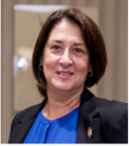
Sharon A. Koches is the 2021 President of the CPCU Society Leadership Council, serving over 15,000 members globally. As founder and CEO of Managing Performance, LLC, Sharon provides P&C consulting and human capital development solutions for insurance companies and their agency distribution networks. Sharon’s areas of expertise include Independent Agency Operations, Large Account Alternative Market Underwriting, Insurance Association Management, and Training. She holds the CPCU, RPLU, AAI, AU, and ITP Designations.

Devi Mohanty, USAA
Vice President, Product Development & Innovation
Topic: Innovation in Insurance
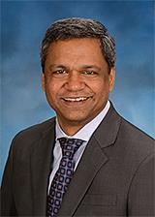

Devi leads the Auto Product Development team to coordinate activities across the enterprise on shaping disruption as the auto insurance industry goes through an evolution with emerging models of mobility. His leadership has been instrumental in the development of SafePilot™, USAA’s proprietary behavior-based insurance auto policy enhancement leveraging telematic technologies. Devi earned a Bachelor of Science from the University of Delhi in Physics and has an MBA from the Indian Institute of Management, Ahmedabad as well as an MBA from the Booth School of Business at the University of Chicago. In his free time, Devi likes to spend time with his family, wife and two kids, running and biking, listening to podcasts, music and movies.

Traci Adedeji, CPCU, ARM, API, AIDA
AIO Program Lead, AIPSO Insurance Operations
Topic: Diversity and Inclusion

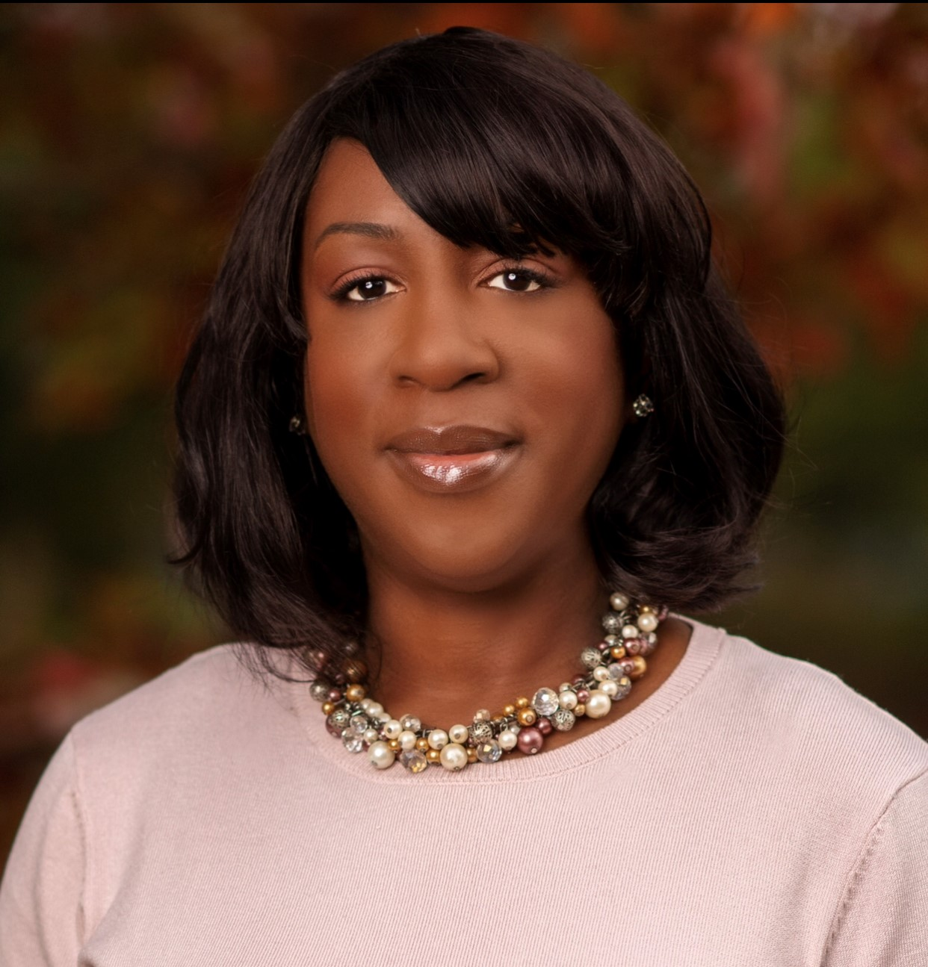

Traci Adedeji is the President of the Rhode Island CPCU chapter where she has served as a volunteer leader for 5 years. She is currently a member of the Society’s Leadership Council where she works as liaison to the Membership Committee. Her past volunteer service to the Society at the national level includes terms on the D&I and Annual Meeting committees. Traci is the Insurance Operations Program Lead at AIPSO in Johnston, RI, working with residual market automobile insurance plans. Her insurance career began on the agent/broker side of the industry and her 30+ years of experience includes leadership roles with several national carriers such as Chubb and AIG. Her expertise is in personal lines underwriting. Traci is a native of Newark, NJ, where she attended Rutgers University. She currently resides in Pawtucket, RI and enjoys cooking, reading and bike riding in her spare time.

Josh Louwagie, Verisk
Matt Frei, Verisk
Topic: Future of Insurance

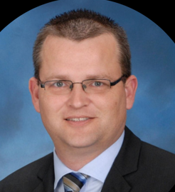

Josh Louwagie is a Director of Product Innovation at Verisk and leads the VISC digital media forensic development. Josh began his career as a Peace Corps volunteer in Paraguay from 2001 – 2003. He then transitioned to work in the insurance industry where he has held a variety of front line and leadership claim positions ever since. Josh is a graduate from Southwest Minnesota State University where he obtained degrees in Finance and Business Administration. He has obtained his CPCU, AIC, AIS, AINS, CCLA, and SCLA designations. He has also obtained the Green Belt Six Sigma Designation and is a certified Safe Agilest. During his spare time, Josh enjoys spending time with his wife and three children and is a proud Shriner who volunteers his time raising money for the Shriners Hospitals for Children.

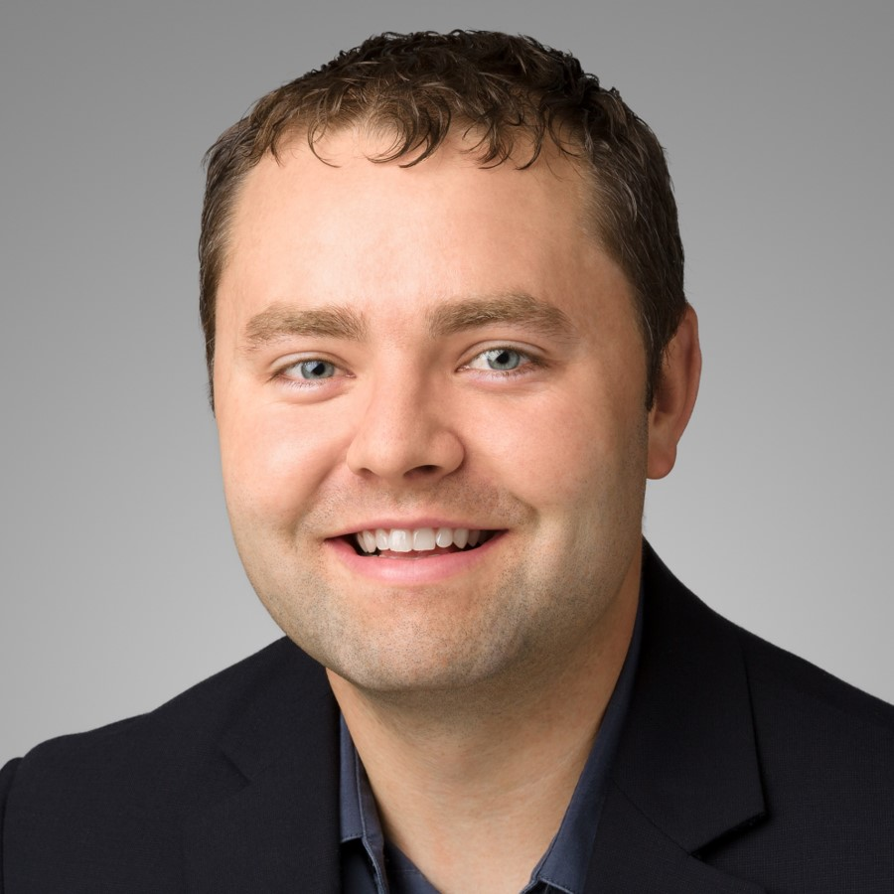

Matt Frei is Director of Data Science at Verisk and leads a team focused on applying AI to streamline the handling of claims with a special focus on Computer Vision technology. His background is in claims fraud detection and automation and he has a strong interest in the latest technologies. Matt is a graduate of North Carolina State University’s Institute for Advanced Analytics. Before entering the insurance world, Matt applied his analytical skills to nonpartisan political research, including working at the Pew Research Center in Washington DC where he conducted and published highly visible, data-centered analysis of national attitudes and trends.

Erick Sawyer, Chief Compliance Officer InHabit
Topic: Professional Development

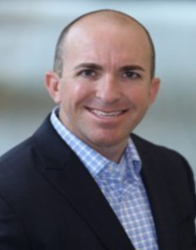

Erick Sawyer is a Financial Services Leader experienced in developing and integrating quality and compliance controls, risk management practices, and enabling business units to operationalize, monitor, and improve performance. He has over 15 years of insurance industry experience in both personal and commercial lines with 10 years of operational risk management expertise.
Erick is currently the Chief Compliance Officer at InhabitIQ, a collective of tech-forward companies leading the residential, commercial and vacation rental industries. In his current role, he is responsible for the Corporate Compliance Program supporting nearly 40 brands and 6 unique divisions within the United States, Canada, and the United Kingdom.

Precious Norman-Walton
Risk Management Insurance and Human Resources Professional
Topic: Professional Networking

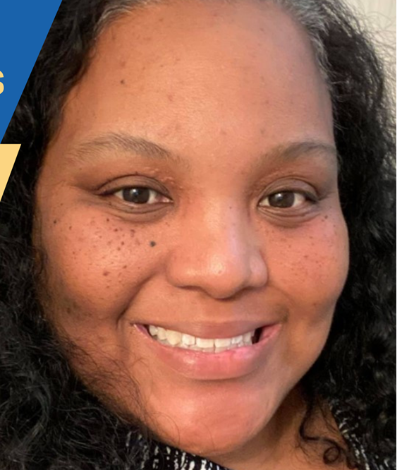

Precious Norman-Walton is the President of Lovejoy Risk Management Corp, out of Dallas, TX. With over 15 years of Insurance Industry experience, she has served in Personal Lines Claims, Commercial Underwriting, and Agency Management. Prior to her current role, Precious was VP of Account Management for Insureon, VP of Agency Operations for Lucky Truck, and Chief Operation Officer for Diamond National Insurance Advisors. She has also served as the President of the Dallas Chapter CPCU Society in 2020.

Precious Norman-Walton holds active licenses as a Risk Manager, Property & Casualty Agent, Life & Health Agent, and All Lines Adjuster, as well as six, destine insurance Designations, and is a SHRM Certified Professional in Human Resources.

Timothy D. Christ, MBA
Topic: The Future of Claims and Technology

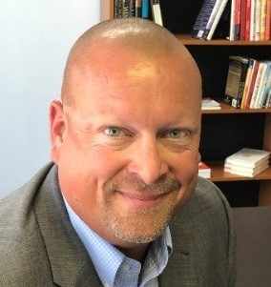

Mr. Christ is an insurance industry veteran, international speaker, thought leader, and 2-time author. He has 20 years’ executive leadership and insurance operations experience. For over 15 years, he worked in forensic engineering to investigate claims and help insureds rebuild businesses after major disasters. He serves as the VP of Growth at Claimatic, an InsurTech startup based in San Antonio, an intelligent decisioning SaaS that automates insurers’ claims processes.

He speaks on leadership, strategy, business operations, employee development, technology, insurance, and forensic engineering topics both nationally and internationally. He has a tireless devotion to growing businesses and helping people. He loves to teach and educate on his areas of expertise. He has served as an Adjunct Professor at University of Texas-Brownsville, Park University in San Antonio, and St. Edwards University in Austin. He also greatly enjoys spending time with his family. His wife, Betty, is a 22-year tax accountant at Valero’s Global HQ and their 8-yr old, Kaleb who is an accomplished athlete in select football, select basketball, select baseball, Little Linksters golf, 5k races, and duathlon competitions.

Thanks to all our guest speakers
and thank YOU for attending!!

